Dear Participant,

We are pleased to welcome you to (name of meeting) to take place on (date and time of meeting). The meeting is taking place in web-ex and participants should connect to this platform by clicking the below link.

(link to web-ex)

For this meeting, we are able to offer simultaneous online interpretation to and from the Russian language in a separate app called Congress Rental Network. Please read the below instructions for accessing the app.

- Download: “Congress Rental Network” app on Apple Store for Apple products (mobile phone, Ipad) or on Google Play for Android Products.
  - 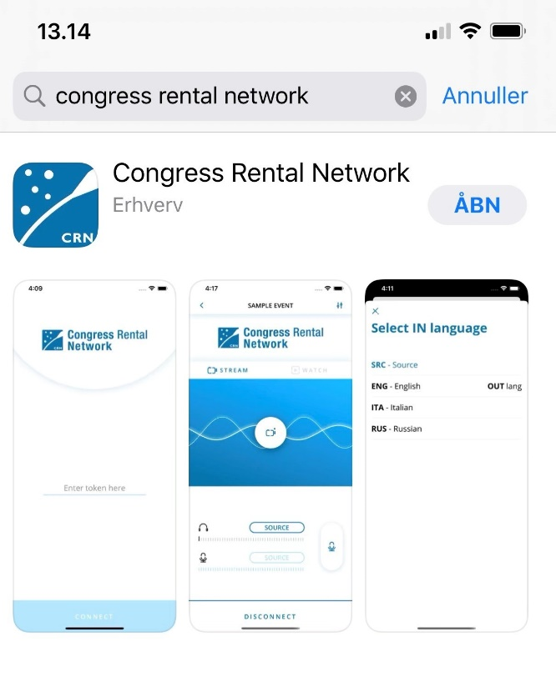
- Make sure a headset is connected to your phone/Ipad.

- Once the app is downloaded, access the app by adding the following code (only use small letters):
7jeinze6

- You will then be prompted to choose a language – options are: a) SRC = source, i.e. the language spoken by the presenter, b) Russian

- 